# **Jenkins with Locust**

Check for the locust installation(wsl): pip install locust

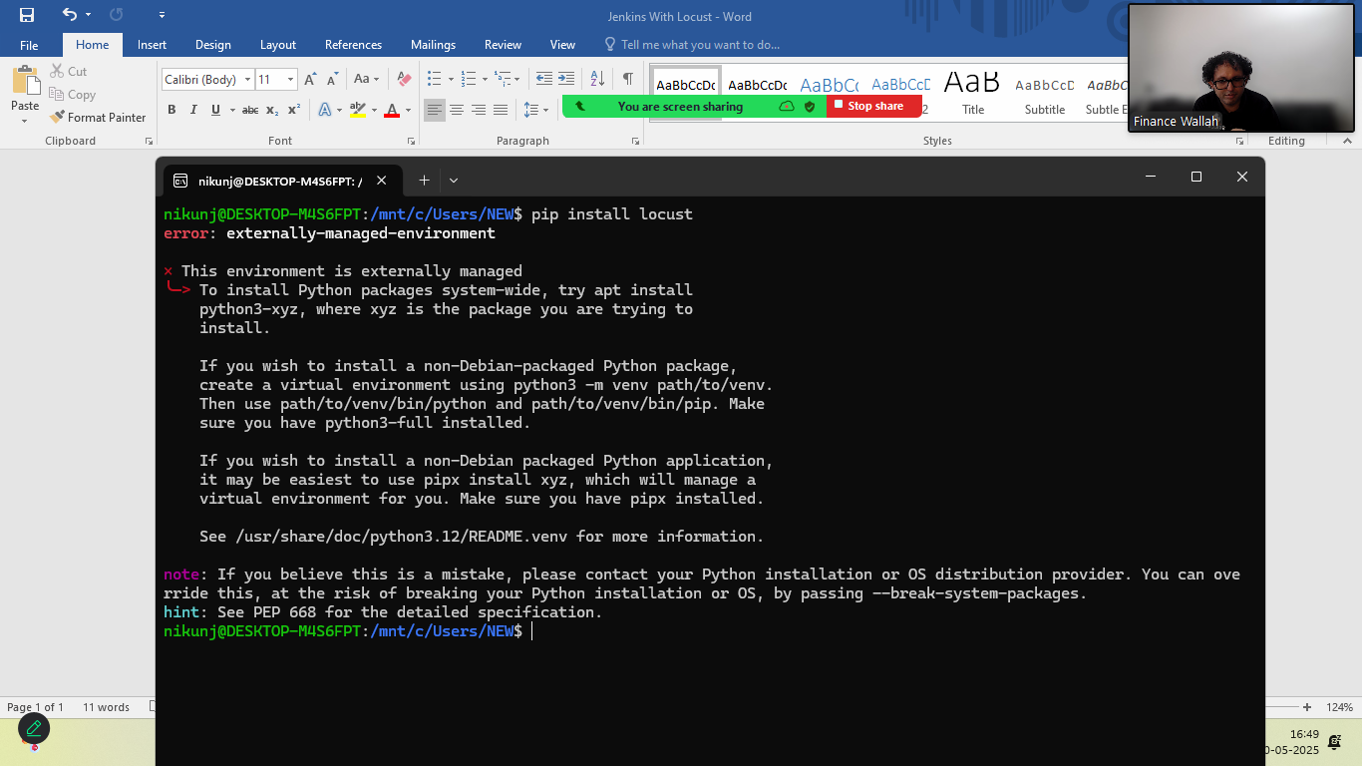

Install via virtual environment

Step:1 ensure python3-venv is installed

* sudo apt install python3-venv python-3-full –y

Step:2 create virtual environment

* python3 –m venv venv

step:3 activate your virtual Environment

* source venv/bin/activate

step:4 you can install packages safely

* pip install –upgrade pip
* pip install locust

Start the Jenkins

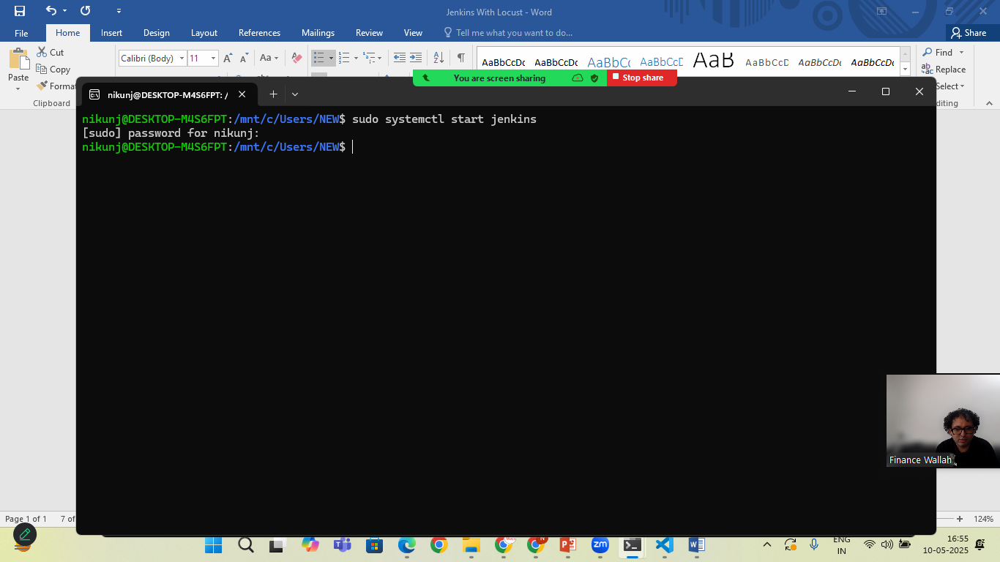

Goto? Browser>localhost:8080 +enter

Create Jenkins Pipline

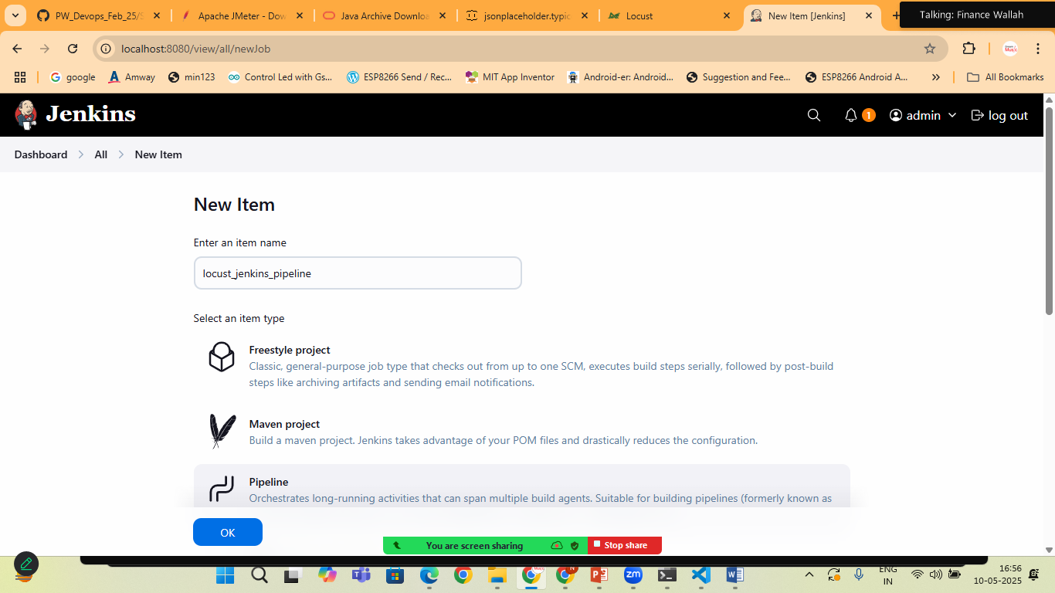

Write the pipline

pipeline {

agent any

stages{

stage('setup python environment'){

steps{

sh '''

python3 -m venv venv

. venv/bin/activate

pip install --upgrade pip

pip install locust

'''

}

}

stage('Run Locust Tests'){

steps{

sh '''

. venv/bin/activate

locust -f locustfile.py

'''

}

}

}

}

Goto wsl and create the locustfile.py

* cd /var/lib/Jenkins/workspace/
* ls
* cd /<yourjob-name>
* sudo touch locustfile.py
* sudo chmod -R u+w /var/lib/jenkins/workspace/locust_jenkins_pipeli

ne/locustfile.py

* sudo nano locustfile.py

copy the script

from locust import HttpUser, task,between

class JsonPlaceholderUser(HttpUser):

wait_time=between(1,2)

host="http://jsonplaceholder.typicode.com"

@task

def get_users(self):

self.client.get("/users")

press ctr+s | ctr+o and save it

* goto jenkins and build the pipline
* open the browser: localhost:8089 and check the result

